**Lab3 Benchmark Results**

**Maximum number of connections that can be handled by the server before any connection drops:** ~2500

**Maximum number of requests per second (RPS) that can be sustained by the server when operating with maximum number of connections:** 689.56/sec (mean)

**Average response time or latency per request:** 1.450ms

**99 percentile response time or latency per request:** 3584ms

**Utilization of CPU, memory, disk IO, and network when max performance is sustained (dstat):**

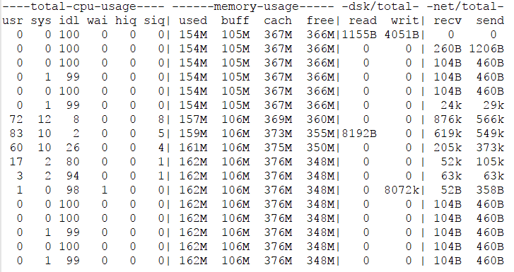

**Full AB Run Results:**

This is ApacheBench, Version 2.3 <$Revision: 1706008 $>

Copyright 1996 Adam Twiss, Zeus Technology Ltd, http://www.zeustech.net/

Licensed to The Apache Software Foundation, http://www.apache.org/

Benchmarking ec2-34-237-5-126.compute-1.amazonaws.com (be patient)

Completed 250 requests

Completed 500 requests

Completed 750 requests

Completed 1000 requests

Completed 1250 requests

Completed 1500 requests

Completed 1750 requests

Completed 2000 requests

Completed 2250 requests

Completed 2500 requests

Finished 2500 requests

Server Software:

Server Hostname: ec2-34-237-5-126.compute-1.amazonaws.com

Server Port: 80

Document Path: /search?keywords=toronto

Document Length: 0 bytes

Concurrency Level: 2500

Time taken for tests: 3.625 seconds

Complete requests: 2500

Failed requests: 0

Non-2xx responses: 2500

Total transferred: 762500 bytes

HTML transferred: 0 bytes

Requests per second: 689.56 [#/sec] (mean)

Time per request: 3625.495 [ms] (mean)

Time per request: 1.450 [ms] (mean, across all concurrent requests)

Transfer rate: 205.39 [Kbytes/sec] received

Connection Times (ms)

min mean[+/-sd] median max

Connect: 0 341 409.5 203 1188

Processing: 125 1207 984.6 989 3315

Waiting: 125 1207 984.7 989 3315

Total: 144 1548 1043.4 1614 3609

Percentage of the requests served within a certain time (ms)

50% 1614

66% 2074

75% 2311

80% 2475

90% 3020

95% 3316

98% 3447

99% 3584

100% 3609 (longest request)